Fix Network Computers are Not Visible in Windows 10 Version 1803
- Press Win + R to open the Run dialog.
- Type services.msc in the Run box and hit the Enter key.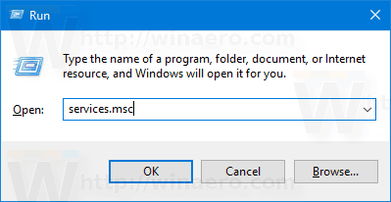
- In the Services window, scroll down to the Function Discovery Resource Publication service.
- Double-click it to open its properties and set its startup type to Automatic.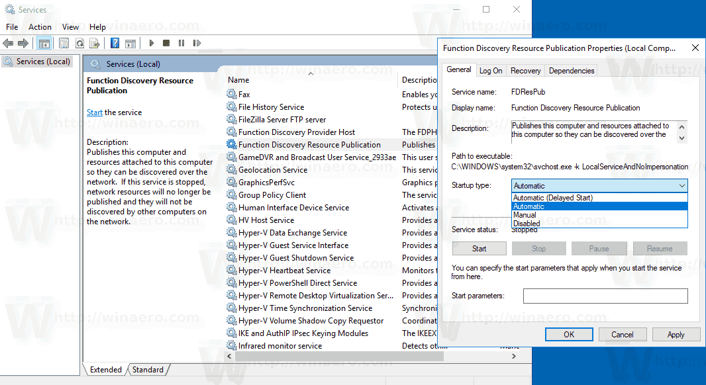
- Now, start the service.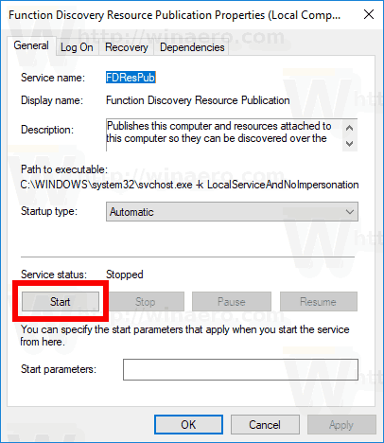
You are done!

