All menu options:
CONFIG Configure EVSE with Type 2 Socket or Fixed cable
LOCK Enable or disable the locking actuator (config = socket)
Disabled No lock is used
Solenoid Dostar, DUOSIDA DSIEC-ELB or Ratio lock
Motor Signal wire reversed, DUOSIDA DSIEC-EL or Phoenix Contact
MODE Use Normal EVSE mode, or Smart/Solar Mode (requires sensorbox)
Normal The EV will charge with the current set at MAX Smart The EV will charge with a dynamic charge current, depending on sensorbox data, and MAINS, MAX, MIN settings. Solar The EV will charge on solar power.
START set the current on which the EV should start Solar charging
-0 -48A (sum of all phases)
STOP Stop charging when there is not enough solar power available
Disabled - 60 minutes (Disabled = never stop charging)
IMPORT Allow additional grid power when solar charging (0-20A)

LOAD BAL Load Balancing mode for 2 to 8 EVSE’s
Disabled load balancing is not used
Master Set the first of the EVSE’s to Master,
Node1-7 And the rest to Node 1-7, when using load balancing.
MAINS Set Max Mains current 10-200A
MIN Set MIN charge current for the EV. 6-16A (per phase)
CIRCUIT Set the max current the EVSE circuit can handle (load balancing)
10-200A
MAX Set MAX charge current for the EV. 10-80A (per phase)
SWITCH Set the function of an external switch connected to pin SW
Disabled A push button on io pin SW can be used to STOP charging. Access B/S An external switch is used to enable/disable access to the charging station. B=momentary pushbutton, S=toggle switch.
Sma-Sol B/S A switch is used to switch between Smart and Solar modes.
RCMON RCM14-03 Residual Current Monitor is plugged into connector P1.
Disabled The RCD option is not used.
Enabled When a fault current is detected, the contactor will be opened.
RFID use a RFID card reader to enable/disable access to the EVSE. A maximum of 20 RFID cards can be stored.
Disabled / Enabled / Learn / Delete / Delete All
MAINSMET Set type of MAINS meter
Sensorbox the Sensorbox will send measurement data to the SmartEVSE.
Phoenix C / Finder / Eastron / Custom a Modbus kWh meter is used.
MAINSADR Set the Modbus address for the kWh meter
EV METER Set type of EV kWh meter (measures power and charged energy)
Disabled / Phoenix / Finder / Eastron / ABB / Custom
EV ADR Set the Modbus address for the EV Meter
4
GRID 3 or 4 wire. Only visible when Sensorbox with CT’s is used.
CAL Calibrate CT1. CT2 and CT3 will use the same cal value.
6.0-99.9A A minimum of 6A is required in order to change this value.
Hold both < and > buttons to reset to default settings.
WiFi Connect to WiFi access point Disabled/Enable/SetupWifi SetupWifi will enable a Wifi portal to setup the Wifi settings.

Load Balancing
Up to eight SmartEVSE modules can share one mains supply.
Software configuration
Set one modules LOAD BAL setting to MASTER, the others to NODE 1-7. Make sure there is only one Master, and the Node numbers are unique.
On the Master configure the following:
MODE Set this to Smart if a Sensorbox (or configured kWh meter) is used to measure the current draw on the mains supply.
It will then dynamically vary the charge current for all connected EV’s. If you are using a dedicated mains supply for the EV’s you can leave this set to Normal.
MAINS Set to the maximum current of the MAINS connection. If the sensorbox measures a higher current then this value on one of the phases, it will immediately reduce the current to the EVSE’s
CIRCUIT Set this to the maximum current of the EVSE circuit. This will be split between the connected and charging EV’s.
MAX Set the maximum charging current for the EV connected to -this- SmartEVSE.
MIN Set to the lowest allowable charging current for all connected EV’s.
On the Node’s configure the following:
MAX Set the maximum charging current for the EV connected to -this- SmartEVSE.
Hardware connections
Connect the A, B and GND connections from the Master to the Node(s).
So A connects to A, B goes to B etc.
If you are using Smart/Solar mode, you should connect the A, B , +12V and
GND wires from the sensorbox to the same screw terminals of the SmartEVSE.
! Make sure that the +12V wire from the sensorbox is connected to only -one– SmartEVSE.

Designed and manufactured in The Netherlands by

Westeinde 15 | 1606 CZ Venhuizen | The Netherlands www.stegen.com | +31 228 8512 19

Charge controller for electric vehicles
SOFTWARE VERSION 3.00
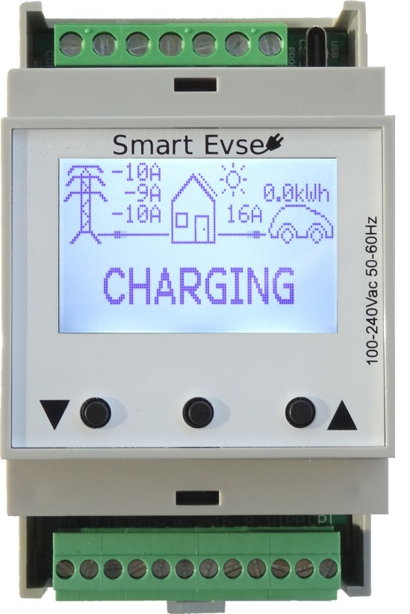
Description
The SmartEVSE is a J1772 / IEC61851 compatible charge controller for electric vehicles. It features connections for a mains contactor and locking actuator.
Up to eight SmartEVSE modules can be connected together, to allow for load balacing between charging stations. All module parameters can be configured using the display and buttons.

Safety notes and warning instructions
! Read the installation instructions completely.
- Installation, operation and maintenance may only be caried out by qualified electricians. Follow the installation instructions as described.
- When installing the controller, use a suitable voltage measuring device to ensure that no mains voltage is present.
Building the EVSE
In order to build a complete EVSE (charging station) you will need:
- SmartEVSE.
- 4 pole NO Contactor with 230V coil, rated for the max charging current.
- Fixed charging cable or socket with locking actuator.
- Enclosure with DIN rail. (EPN2205 or Famatel type 3958)
- optional Residual Current Monitor to protect against DC residual currents
- Terminal blocks (Wago TOPJOB S)
When using a fixed charging cable, please check if there is a resistor between PP and PE in the Charging Plug. Otherwise the EV will not start charging.
220 Ohm = 32A Cable 680 Ohm = 16A Cable
This resistor determines the max charge current the cable can handle, and is already fitted on all factory made cables.

Do not connect the PP wire to the SmartEVSE, if using a fixed cable!
! The EVSE needs to be protected with a circuit breaker and residual- current circuit breaker, usually located near or in the distribution board.

The contactor should be connected to terminals N and C1.
The C2 output is for future use, and will drive a second contactor.

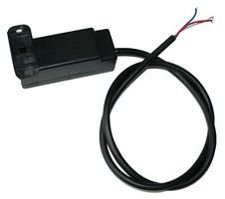
Diagram
1
Low voltage connections
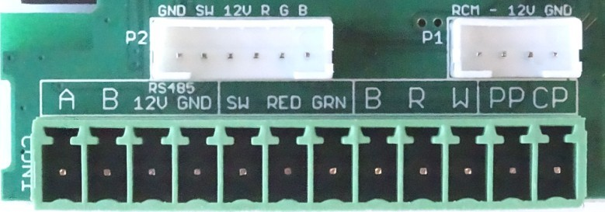

All low voltage connections are made with a 12 pin pluggable connector.

A, B, 12V and GND connections are used to connect the sensorbox. (optional) A, B and GND should be connected to each module if you choose to use load balancing between SmartEVSE modules.
A 12v LED can be connected between the 12V(+) and the RED(-) and GRN(-) terminals. You can also connect a ready made cable to connector P2. An (optional) switch can be connected to the SW terminal and GND. It can be used to start/stop charging and toggle between charge modes. The (optional) RCM14-03 residual current sensor should be connected to connector P1.
B, R, W (lock) need to be connected to the locking solenoid or 12V motor that will lock the charging cable in it’s socket. (see next page)
PP (proximity pilot) signal will determine what max current the charging cable can handle, and needs to be connected to the charging socket. In case of a fixed cable, this signal is not used.
CP (control pilot) signal communicates with the EV, and will also inform the EV the maximum allowed charging current. This signal needs to be connected to the CP pin of the charging socket, or connected to the CP wire if using a fixed cable. The maximum total length of the CP wire+ charging cable is 15meter.

The SmartEVSE is capable of dynamically adjusting the chargecurrent, depending on other loads that use the same mains connection. We call this smart mode, and it will require the following extra items:
• ‘Sensorbox plus’ with Current Transformers, one for each phase or ‘Sensorbox 2’ and a compatible smart meter with P1 port. • 4+ wire cable for the connection between SmartEVSE and Sensorbox.
The Sensorbox should be placed where the mains connection enters the building. Usually this is just after the kWh meter, this allows it to measure the total current for each phase and send this information to the SmartEVSE.
Clip the current transformers on the L1,L2 and L3 wires, and plug the other end of each cable into the Sensorbox.
For the Sensorbox2, plug the RJ12 cable into the smart meter and Sensorbox2
The data cable coming from the Sensorbox should be connected to terminals A, B, +12V and — GND of the SmartEVSE.
This data cable can be more then 100 meters if needed.

2
The Locking Actuator
A locking actuator can be used to lock the charging plug into the socket. It will lock the cable when charging starts, and will unlock the cable after charging has stopped.
The SmartEVSE supports at least five types of locking actuators:

The Dostar DSIEC-EL lock has three wires and can be connected directly to the B(lue) R(ed) W(hite) terminals on the module.
Sometimes it locks, while it should unlock, you will then have to swap the Red and White wires.
Set the Lock option in the menu to SOLENOID

The DUOSIDA DSIEC-EL lock has 4 wires, connect them as follows:
B: Blue R: Yellow+White W: Red
Set the Lock option in the menu to MOTOR

The DSIEC-ELB lock has 3 wires, connect them as follows:
B: Blue R: White W: Red
Set the Lock option in the menu to SOLENOID

The DSIEC-ELC lock will not work with the SmartEVSE !
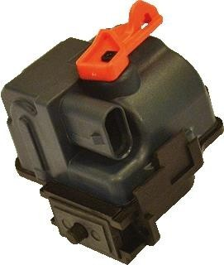
The Ratio lock has 3 wires, connect them as follows:
B: Blue R: Black W: Red
Set the Lock option in the menu to SOLENOID
The Phoenix contact locking motor has 4 wires and needs to be connected as follows: B: BL/YL R: BL/GR + BL/BR W: BL/RD
Set the Lock option in the menu to MOTOR
When using a fixed charging cable, this function is not visible in the menu.

Error Messages
If an error occurs, the SmartEVSE will stop charging, and display one of the following messages:
ERROR NO SERIAL COM CHECK WIRING No signal from the Sensorbox or other SmartEVSE (when load balancing is used) has been received for 10 seconds. Please check the wiring to the Sensorbox or other SmartEVSE.
ERROR NO CURRENT There is not enough current available to start charging, or charging was interrupted because there was not enough current available to keep charging. The SmartEVSE will try again in 60 seconds.
ERROR HIGH TEMP The temperature inside the module has reached 65º Celsius. Charging is stopped.
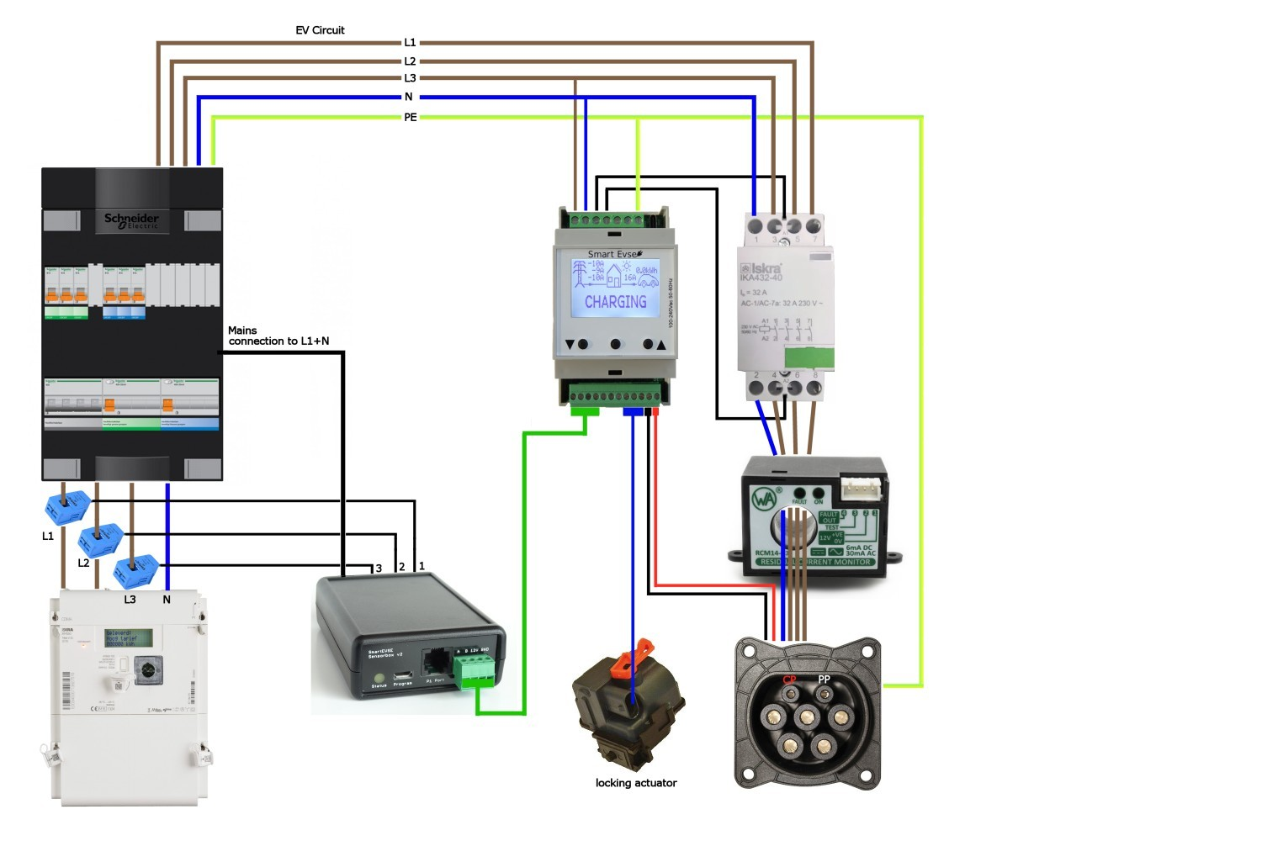
Once the temperature has dropped below 55ºC charging is started again.
Sensorbox (optional)

RESIDUAL FAULT CURRENT DETECTED An optional DC Residual Current Monitor has detected a fault current, the Contactor is switched off. The error condition can be reset by pressing any button on the SmartEVSE.
3

